**Pipeline:-**

In simple words, we use pipelines in Python to streamline and automate a series of tasks or processes. Just like a real-world pipeline connects different stages to transport something from one place to another, a Python pipeline connects various steps of a program to process data efficiently.

Imagine you have a series of tasks to perform on some data, like data cleaning, feature selection, model training, and prediction. Instead of manually running each step one by one, a pipeline allows you to automate the entire process. It ensures that data flows smoothly from one step to the next, making your code more organized, maintainable, and easier to manage.

Pipelines also help improve code reusability because you can reuse the same pipeline structure for different datasets or projects. Additionally, they can enhance the reproducibility of your work since you can easily replicate the entire data processing and analysis workflow with just a few lines of code.

So, in essence, pipelines in Python simplify and optimize complex data processing tasks by connecting and automating various steps, making your code more efficient and effective.

Top of Form

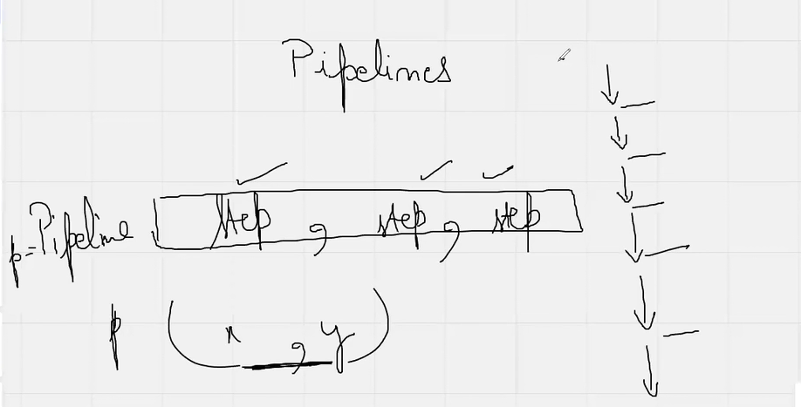

**Gradient Descent Algorithm:-**

Linear model makes a prediction by simply computing a weighted sum of the input features, plus a constant called the bias term (also called the intercept term)

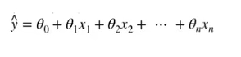Linear Regression expression

**Cost Function**

Cost Function is a function that measures the performance of a model for any given data. Cost Function quantifies the error between predicted values and expected values and presents it in the form of a single real number.

MSE Cost Function--- Mean Squared Error Cost Function

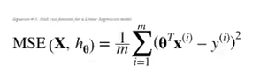

And with a goal to reduce the cost function, we modify the parameters by using the Gradient descent algorithm over the given data.

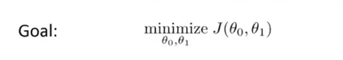

**Gradient descent**

Gradient descent is an iterative optimization algorithm for finding the local minimum of a function. Gradient descent is simply function's parameters (coefficients) that minimize a cost function as far as possible.

In other words, Gradient descent is an optimization algorithm used to minimize some function by iteratively moving in the direction of steepest descent as defined by the negative of the gradient. In machine learning, we use gradient descent to update the parameters of our model. Parameters refer to coefficients in Linear Regression and weights in neural networks

A gradient measures how much the output of a function changes if you change the inputs a little bit

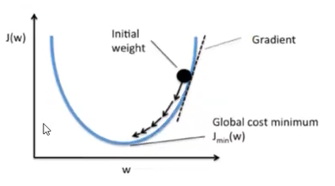

**Learning rate**

The size of these steps is called the learning rate. With a high learning rate we can cover more ground each step, but we risk overshooting the lowest point since the slope of the hill is constantly changing. With a very low learning rate, we can confidently move in the direction of the negative gradient since we are recalculating it so frequently.

TYPES OF GRADIENT DESCENT--

STOCASTIC GRADIENT DESCENT- Stochastic Gradient Descent (SGD) is a simple yet very efficient approach to fitting linear classifiers and regressors under convex loss functions such as (linear) Support Vector Machines and Logistic Regression.

**Tuning the model: Hyperparameter tuning : GridSearchCV,RandomizedSearchCV**

**Grid Search CV:-**

GridSearchCv is used for hyper parameter tuning.Using GridSearchCv we can use all models different different parameter in one go like ,svc() has a parameter named kernel and in kernel parameter there are three values ”rvf”,”poly”,”linear” .So using GridSearchcv we can first check that which parameter value works better.Like for Svc bases on the score if I see that “linear” works better then you can continue machine learning with svc with kernel=”linear” model .

You have to use GridSearchCV like this:

GridSearchCV(model name,{parameter in dictionary format},cv=5)

**RandomizedSearchCV:-**

Unlike GridSearchCv RandomizedSearchCV can not check all parameter values it randomly select two or three and give the result of best parameter.So it works quicker but not that effective.